1 run

training 1 epoch...

150.82197618484497 seconds used......

1 training finished! average train loss: 0.6236351070837296

evaluating...

Confusion matrix, without normalization

[[ 619 229 174]

[ 567 4660 180]

[ 760 346 9659]]

Normalized confusion matrix

[[0.60567515 0.22407045 0.1702544 ]

[0.10486407 0.86184576 0.03329018]

[0.07059916 0.0321412 0.89725964]]

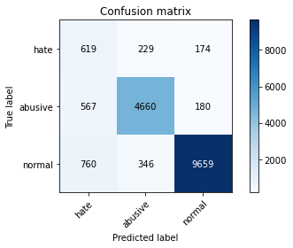

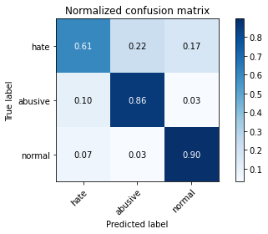

precision recall f1-score support

hate 0.32 0.61 0.42 1022

abusive 0.89 0.86 0.88 5407

normal 0.96 0.90 0.93 10765

accuracy 0.87 17194

macro avg 0.72 0.79 0.74 17194

weighted avg 0.90 0.87 0.88 17194

average eval_loss: 0.3981050635752983, accuracy: 0.8687914388740258

training 2 epoch...

150.8350305557251 seconds used......

2 training finished! average train loss: 0.4612427066767727

evaluating...

Confusion matrix, without normalization

[[ 687 209 126]

[ 692 4602 113]

[1477 395 8893]]

Normalized confusion matrix

[[0.67221135 0.20450098 0.12328767]

[0.12798225 0.85111892 0.02089883]

[0.1372039 0.03669299 0.82610311]]

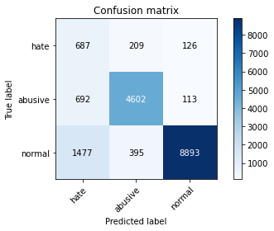

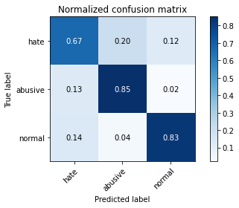

precision recall f1-score support

hate 0.24 0.67 0.35 1022

abusive 0.88 0.85 0.87 5407

normal 0.97 0.83 0.89 10765

accuracy 0.82 17194

macro avg 0.70 0.78 0.71 17194

weighted avg 0.90 0.82 0.85 17194

average eval_loss: 0.4818759852457185, accuracy: 0.8248226125392579

training 3 epoch...

150.8386652469635 seconds used......

3 training finished! average train loss: 0.3527399504023266

evaluating...

Confusion matrix, without normalization

[[ 815 133 74]

[1355 3962 90]

[2976 210 7579]]

Normalized confusion matrix

[[0.79745597 0.13013699 0.07240705]

[0.25060107 0.73275384 0.01664509]

[0.27645146 0.01950766 0.70404087]]

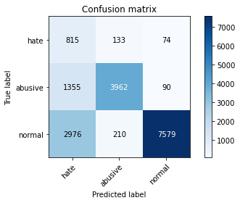

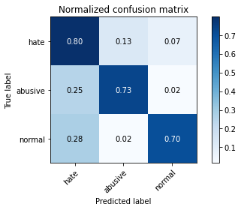

precision recall f1-score support

hate 0.16 0.80 0.26 1022

abusive 0.92 0.73 0.82 5407

normal 0.98 0.70 0.82 10765

accuracy 0.72 17194

macro avg 0.69 0.74 0.63 17194

weighted avg 0.91 0.72 0.79 17194

average eval_loss: 0.7663834923401821, accuracy: 0.7186227753867628

training 4 epoch...

150.70885705947876 seconds used......

5 training finished! average train loss: 0.15953167570590907

evaluating...

Confusion matrix, without normalization

[[ 690 175 157]

[ 894 4280 233]

[1420 274 9071]]

Normalized confusion matrix

[[0.67514677 0.17123288 0.15362035]

[0.16534122 0.79156649 0.04309229]

[0.13190896 0.02545286 0.84263818]]

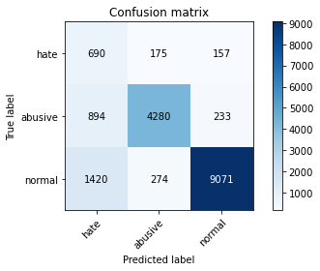

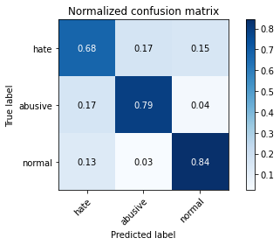

precision recall f1-score support

hate 0.23 0.68 0.34 1022

abusive 0.91 0.79 0.84 5407

normal 0.96 0.84 0.90 10765

accuracy 0.82 17194

macro avg 0.70 0.77 0.69 17194

weighted avg 0.90 0.82 0.85 17194

average eval_loss: 0.7026604440648022, accuracy: 0.8166220774688845

training 6 epoch...

150.71261382102966 seconds used......

6 training finished! average train loss: 0.11894784779361456

evaluating...

Confusion matrix, without normalization

[[ 620 249 153]

[ 742 4523 142]

[1331 421 9013]]

Normalized confusion matrix

[[0.60665362 0.24363992 0.14970646]

[0.13722952 0.83650823 0.02626225]

[0.12364143 0.03910822 0.83725035]]

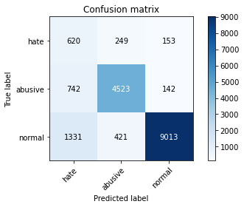

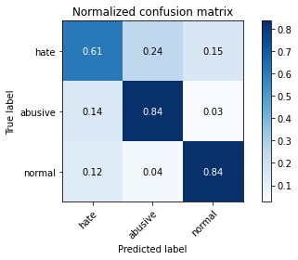

precision recall f1-score support

hate 0.23 0.61 0.33 1022

abusive 0.87 0.84 0.85 5407

normal 0.97 0.84 0.90 10765

accuracy 0.82 17194

macro avg 0.69 0.76 0.70 17194

weighted avg 0.89 0.82 0.85 17194

average eval_loss: 0.7308838985719567, accuracy: 0.8233104571362103

training 7 epoch...

150.84873008728027 seconds used......

7 training finished! average train loss: 0.08150948416052751

evaluating...

Confusion matrix, without normalization

[[ 636 195 191]

[ 744 4413 250]

[ 950 277 9538]]

Normalized confusion matrix

[[0.6223092 0.19080235 0.18688845]

[0.13759941 0.81616423 0.04623636]

[0.08824895 0.02573154 0.88601951]]

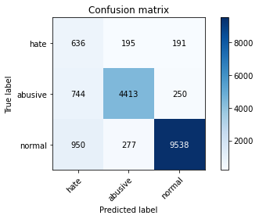

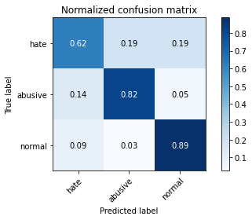

precision recall f1-score support

hate 0.27 0.62 0.38 1022

abusive 0.90 0.82 0.86 5407

normal 0.96 0.89 0.92 10765

accuracy 0.85 17194

macro avg 0.71 0.77 0.72 17194

weighted avg 0.90 0.85 0.87 17194

average eval_loss: 0.7551021835448621, accuracy: 0.8483773409328835

training 8 epoch...

150.75391387939453 seconds used......

8 training finished! average train loss: 0.07588124271922662

evaluating...

Confusion matrix, without normalization

[[ 666 196 160]

[ 865 4367 175]

[1463 316 8986]]

Normalized confusion matrix

[[0.65166341 0.19178082 0.15655577]

[0.15997781 0.80765674 0.03236545]

[0.13590339 0.02935439 0.83474222]]

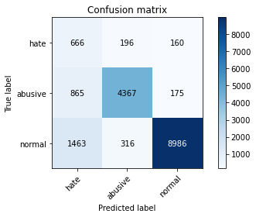

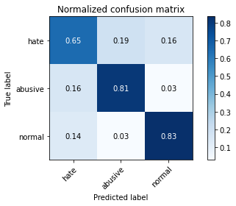

precision recall f1-score support

hate 0.22 0.65 0.33 1022

abusive 0.90 0.81 0.85 5407

normal 0.96 0.83 0.89 10765

accuracy 0.82 17194

macro avg 0.69 0.76 0.69 17194

weighted avg 0.90 0.82 0.85 17194

average eval_loss: 0.8502965265668408, accuracy: 0.8153425613586135

training 9 epoch...

2 run

training 1 epoch...

151.8086678981781 seconds used......

1 training finished! average train loss: 0.60438251411269

evaluating...

Confusion matrix, without normalization

[[ 611 237 174]

[ 554 4709 144]

[ 939 339 9487]]

Normalized confusion matrix

[[0.59784736 0.23189824 0.1702544 ]

[0.10245977 0.87090808 0.02663214]

[0.08722712 0.03149094 0.88128193]]

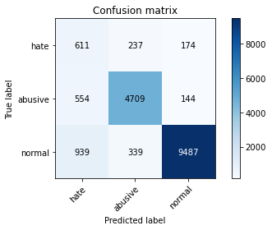

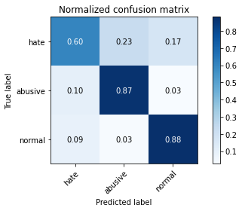

precision recall f1-score support

hate 0.29 0.60 0.39 1022

abusive 0.89 0.87 0.88 5407

normal 0.97 0.88 0.92 10765

accuracy 0.86 17194

macro avg 0.72 0.78 0.73 17194

weighted avg 0.90 0.86 0.88 17194

average eval_loss: 0.4013634535548992, accuracy: 0.8611725020355938

training 2 epoch...

151.26520586013794 seconds used......

2 training finished! average train loss: 0.4472469888442526

evaluating...

Confusion matrix, without normalization

[[ 699 215 108]

[ 681 4631 95]

[1704 412 8649]]

Normalized confusion matrix

[[0.68395303 0.21037182 0.10567515]

[0.12594785 0.85648234 0.01756982]

[0.15829076 0.03827218 0.80343706]]

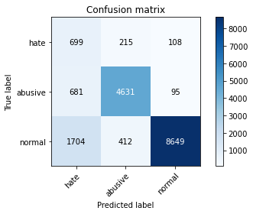

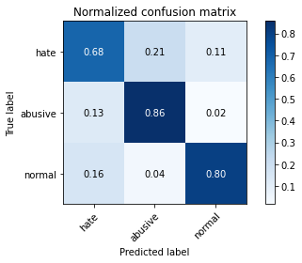

precision recall f1-score support

hate 0.23 0.68 0.34 1022

abusive 0.88 0.86 0.87 5407

normal 0.98 0.80 0.88 10765

accuracy 0.81 17194

macro avg 0.69 0.78 0.70 17194

weighted avg 0.90 0.81 0.85 17194

average eval_loss: 0.5345142028879287, accuracy: 0.813016168430848

training 3 epoch...

151.31790113449097 seconds used......

3 training finished! average train loss: 0.33397239447480936

evaluating...

Confusion matrix, without normalization

[[ 675 196 151]

[ 786 4449 172]

[1356 325 9084]]

Normalized confusion matrix

[[0.66046967 0.19178082 0.14774951]

[0.14536712 0.82282227 0.03181062]

[0.12596377 0.03019043 0.8438458 ]]

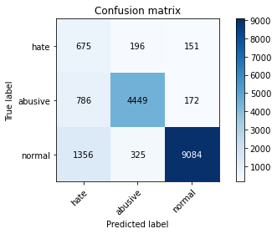

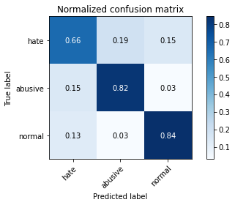

precision recall f1-score support

hate 0.24 0.66 0.35 1022

abusive 0.90 0.82 0.86 5407

normal 0.97 0.84 0.90 10765

accuracy 0.83 17194

macro avg 0.70 0.78 0.70 17194

weighted avg 0.90 0.83 0.85 17194

average eval_loss: 0.49969781296717564, accuracy: 0.8263347679423054

training 4 epoch...

151.41722345352173 seconds used......

4 training finished! average train loss: 0.22733810480944727

evaluating...

Confusion matrix, without normalization

[[ 552 215 255]

[ 652 4517 238]

[ 482 347 9936]]

Normalized confusion matrix

[[0.54011742 0.21037182 0.24951076]

[0.12058443 0.83539856 0.04401701]

[0.04477473 0.03223409 0.92299118]]

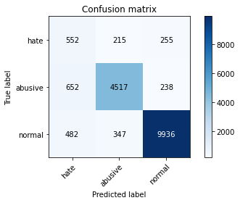

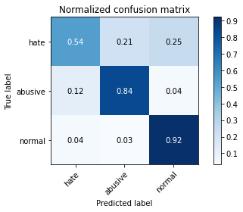

precision recall f1-score support

hate 0.33 0.54 0.41 1022

abusive 0.89 0.84 0.86 5407

normal 0.95 0.92 0.94 10765

accuracy 0.87 17194

macro avg 0.72 0.77 0.74 17194

weighted avg 0.90 0.87 0.88 17194

average eval_loss: 0.4486256949679363, accuracy: 0.872688147028033

training 5 epoch...

151.48217391967773 seconds used......

5 training finished! average train loss: 0.1527677276833971

evaluating...

Confusion matrix, without normalization

[[ 675 181 166]

[ 923 4293 191]

[1360 303 9102]]

Normalized confusion matrix

[[0.66046967 0.17710372 0.16242661]

[0.17070464 0.79397078 0.03532458]

[0.12633535 0.02814677 0.84551788]]

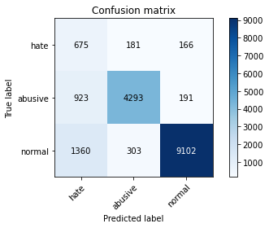

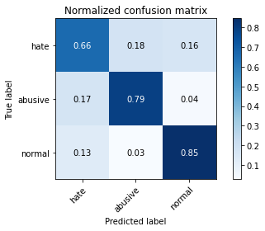

precision recall f1-score support

hate 0.23 0.66 0.34 1022

abusive 0.90 0.79 0.84 5407

normal 0.96 0.85 0.90 10765

accuracy 0.82 17194

macro avg 0.70 0.77 0.69 17194

weighted avg 0.90 0.82 0.85 17194

average eval_loss: 0.7359059604123062, accuracy: 0.8183087123415145

training 6 epoch...

151.43773937225342 seconds used......

6 training finished! average train loss: 0.10975849143761308

evaluating...

Confusion matrix, without normalization

[[ 671 187 164]

[1010 4241 156]

[1470 327 8968]]

Normalized confusion matrix

[[0.65655577 0.18297456 0.16046967]

[0.1867949 0.78435362 0.02885149]

[0.13655365 0.03037622 0.83307013]]

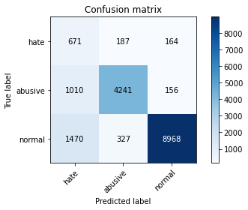

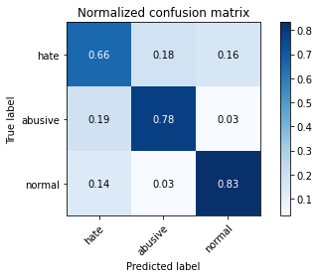

precision recall f1-score support

hate 0.21 0.66 0.32 1022

abusive 0.89 0.78 0.83 5407

normal 0.97 0.83 0.89 10765

accuracy 0.81 17194

macro avg 0.69 0.76 0.68 17194

weighted avg 0.90 0.81 0.84 17194

average eval_loss: 0.8315677267802489, accuracy: 0.8072583459346283

training 7 epoch...

151.28250336647034 seconds used......

7 training finished! average train loss: 0.0821953996473032

evaluating...

Confusion matrix, without normalization

[[ 712 179 131]

[1091 4154 162]

[1853 283 8629]]

Normalized confusion matrix

[[0.69667319 0.17514677 0.12818004]

[0.20177548 0.76826336 0.02996116]

[0.17213191 0.0262889 0.80157919]]

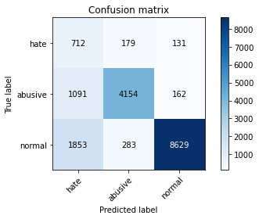

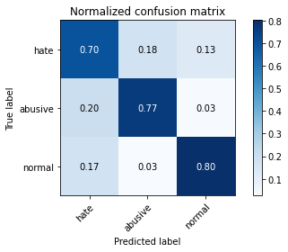

precision recall f1-score support

hate 0.19 0.70 0.30 1022

abusive 0.90 0.77 0.83 5407

normal 0.97 0.80 0.88 10765

accuracy 0.78 17194

macro avg 0.69 0.76 0.67 17194

weighted avg 0.90 0.78 0.83 17194

average eval_loss: 1.0562007427551285, accuracy: 0.7848668140048854

training 8 epoch...

151.2691261768341 seconds used......

8 training finished! average train loss: 0.0804453348787186

evaluating...

Confusion matrix, without normalization

[[ 632 252 138]

[ 684 4602 121]

[1541 440 8784]]

Normalized confusion matrix

[[0.6183953 0.24657534 0.13502935]

[0.12650268 0.85111892 0.0223784 ]

[0.14314909 0.0408732 0.81597771]]

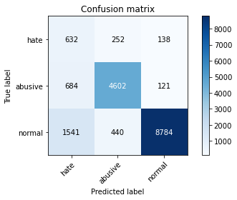

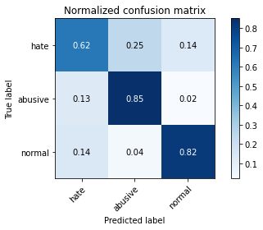

precision recall f1-score support

hate 0.22 0.62 0.33 1022

abusive 0.87 0.85 0.86 5407

normal 0.97 0.82 0.89 10765

accuracy 0.82 17194

macro avg 0.69 0.76 0.69 17194

weighted avg 0.89 0.82 0.85 17194

average eval_loss: 0.936991343649949, accuracy: 0.8152844015354194

training 9 epoch...

151.27520418167114 seconds used......

9 training finished! average train loss: 0.06796902798036845

evaluating...

Confusion matrix, without normalization

[[ 622 229 171]

[ 724 4503 180]

[1028 447 9290]]

Normalized confusion matrix

[[0.60861057 0.22407045 0.16731898]

[0.1339005 0.83280932 0.03329018]

[0.09549466 0.04152346 0.86298189]]

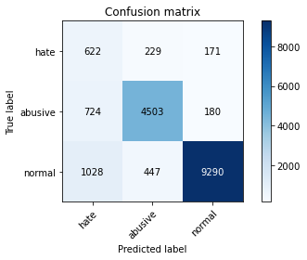

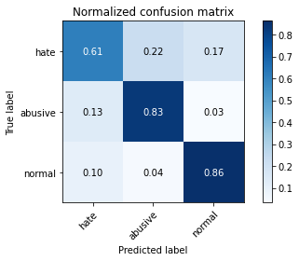

precision recall f1-score support

hate 0.26 0.61 0.37 1022

abusive 0.87 0.83 0.85 5407

normal 0.96 0.86 0.91 10765

accuracy 0.84 17194

macro avg 0.70 0.77 0.71 17194

weighted avg 0.89 0.84 0.86 17194

average eval_loss: 0.8684666185779226, accuracy: 0.838373851343492

training 10 epoch...

151.4560899734497 seconds used......

10 training finished! average train loss: 0.06814770649516277

evaluating...

Confusion matrix, without normalization

[[ 750 168 104]

[1116 4185 106]

[2094 476 8195]]

Normalized confusion matrix

[[0.73385519 0.16438356 0.10176125]

[0.20639911 0.77399667 0.01960422]

[0.19451928 0.04421737 0.76126335]]

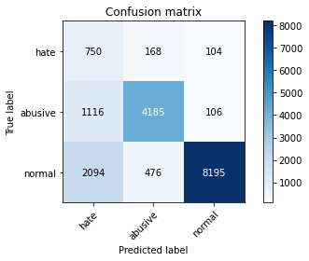

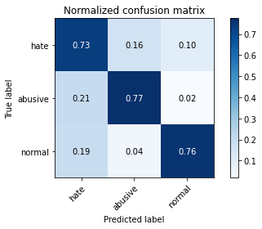

precision recall f1-score support

hate 0.19 0.73 0.30 1022

abusive 0.87 0.77 0.82 5407

normal 0.98 0.76 0.85 10765

accuracy 0.76 17194

macro avg 0.68 0.76 0.66 17194

weighted avg 0.89 0.76 0.81 17194

average eval_loss: 1.2638975511456645, accuracy: 0.7636384785390252

3 run

training 1 epoch...

151.35409665107727 seconds used......

1 training finished! average train loss: 0.5969073216411922

evaluating...

Confusion matrix, without normalization

[[ 611 178 233]

[ 668 4543 196]

[ 490 315 9960]]

Normalized confusion matrix

[[0.59784736 0.1741683 0.22798434]

[0.12354355 0.84020714 0.03624931]

[0.04551788 0.0292615 0.92522062]]

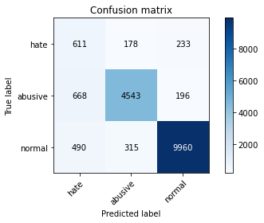

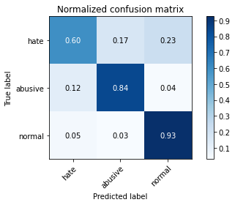

precision recall f1-score support

hate 0.35 0.60 0.44 1022

abusive 0.90 0.84 0.87 5407

normal 0.96 0.93 0.94 10765

accuracy 0.88 17194

macro avg 0.74 0.79 0.75 17194

weighted avg 0.90 0.88 0.89 17194

average eval_loss: 0.37647981581299805, accuracy: 0.8790275677561941

training 2 epoch...

151.40275192260742 seconds used......

2 training finished! average train loss: 0.44338869296737504

evaluating...

Confusion matrix, without normalization

[[ 688 143 191]

[1020 4197 190]

[ 811 253 9701]]

Normalized confusion matrix

[[0.67318982 0.13992172 0.18688845]

[0.18864435 0.77621602 0.03513963]

[0.07533674 0.02350209 0.90116117]]

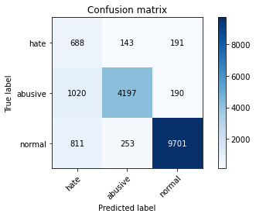

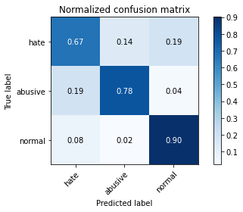

precision recall f1-score support

hate 0.27 0.67 0.39 1022

abusive 0.91 0.78 0.84 5407

normal 0.96 0.90 0.93 10765

accuracy 0.85 17194

macro avg 0.72 0.78 0.72 17194

weighted avg 0.91 0.85 0.87 17194

average eval_loss: 0.4174677048658216, accuracy: 0.8483191811096894

training 3 epoch...

151.4077250957489 seconds used......

3 training finished! average train loss: 0.3241733125585466

evaluating...

Confusion matrix, without normalization

[[ 722 180 120]

[ 943 4377 87]

[1645 529 8591]]

Normalized confusion matrix

[[0.70645793 0.17612524 0.11741683]

[0.17440355 0.8095062 0.01609025]

[0.15281003 0.04914073 0.79804923]]

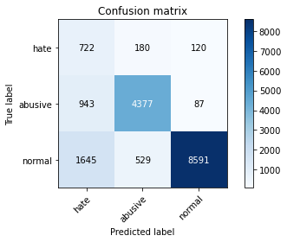

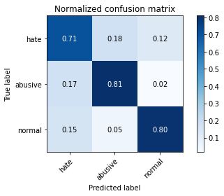

precision recall f1-score support

hate 0.22 0.71 0.33 1022

abusive 0.86 0.81 0.83 5407

normal 0.98 0.80 0.88 10765

accuracy 0.80 17194

macro avg 0.69 0.77 0.68 17194

weighted avg 0.89 0.80 0.83 17194

average eval_loss: 0.6232220564037562, accuracy: 0.7962079795277422

training 4 epoch...

151.3001003265381 seconds used......

4 training finished! average train loss: 0.21796336977345276

evaluating...

Confusion matrix, without normalization

[[ 692 173 157]

[ 925 4299 183]

[1255 267 9243]]

Normalized confusion matrix

[[0.67710372 0.16927593 0.15362035]

[0.17107453 0.79508045 0.03384502]

[0.11658151 0.0248026 0.85861588]]

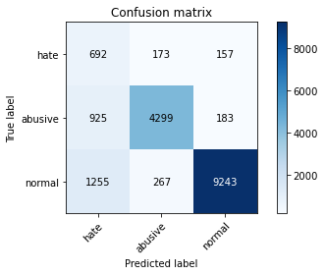

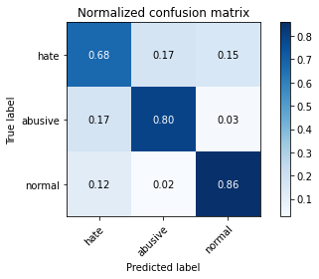

precision recall f1-score support

hate 0.24 0.68 0.36 1022

abusive 0.91 0.80 0.85 5407

normal 0.96 0.86 0.91 10765

accuracy 0.83 17194

macro avg 0.70 0.78 0.70 17194

weighted avg 0.90 0.83 0.86 17194

average eval_loss: 0.5903242950999114, accuracy: 0.827846923345353

training 5 epoch...

151.32338905334473 seconds used......

5 training finished! average train loss: 0.15008352959053445

evaluating...

Confusion matrix, without normalization

[[ 748 185 89]

[1014 4302 91]

[2511 393 7861]]

Normalized confusion matrix

[[0.73189824 0.18101761 0.08708415]

[0.18753468 0.79563529 0.01683004]

[0.23325592 0.0365072 0.73023688]]

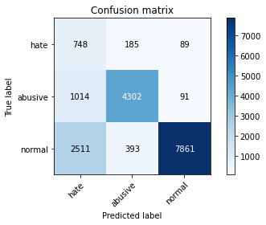

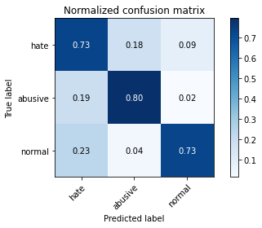

precision recall f1-score support

hate 0.18 0.73 0.28 1022

abusive 0.88 0.80 0.84 5407

normal 0.98 0.73 0.84 10765

accuracy 0.75 17194

macro avg 0.68 0.75 0.65 17194

weighted avg 0.90 0.75 0.80 17194

average eval_loss: 0.9725803806858008, accuracy: 0.7509014772595092

training 6 epoch...

151.34891152381897 seconds used......

6 training finished! average train loss: 0.10396534988749141

evaluating...

Confusion matrix, without normalization

[[ 665 207 150]

[ 762 4492 153]

[1297 372 9096]]

Normalized confusion matrix

[[0.65068493 0.20254403 0.14677104]

[0.14092843 0.83077492 0.02829665]

[0.12048305 0.03455643 0.84496052]]

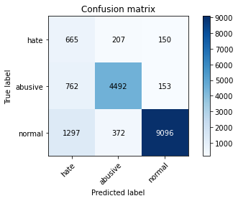

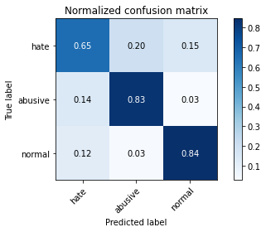

precision recall f1-score support

hate 0.24 0.65 0.36 1022

abusive 0.89 0.83 0.86 5407

normal 0.97 0.84 0.90 10765

accuracy 0.83 17194

macro avg 0.70 0.78 0.70 17194

weighted avg 0.90 0.83 0.86 17194

average eval_loss: 0.8041665256180432, accuracy: 0.8289519599860417

training 7 epoch...

151.19732022285461 seconds used......

7 training finished! average train loss: 0.08174603163216339

evaluating...

Confusion matrix, without normalization

[[ 739 166 117]

[1044 4223 140]

[2044 330 8391]]

Normalized confusion matrix

[[0.72309198 0.16242661 0.11448141]

[0.19308304 0.7810246 0.02589236]

[0.18987459 0.0306549 0.77947051]]

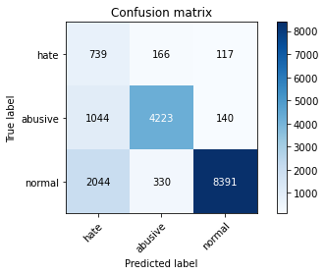

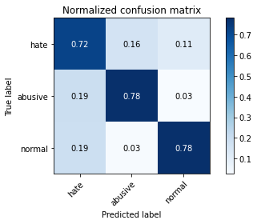

precision recall f1-score support

hate 0.19 0.72 0.30 1022

abusive 0.89 0.78 0.83 5407

normal 0.97 0.78 0.86 10765

accuracy 0.78 17194

macro avg 0.69 0.76 0.67 17194

weighted avg 0.90 0.78 0.82 17194

average eval_loss: 1.0936331714774201, accuracy: 0.7766081191113179

training 8 epoch...

151.17700386047363 seconds used......

8 training finished! average train loss: 0.07950239260570602

evaluating...

Confusion matrix, without normalization

[[ 641 218 163]

[ 719 4527 161]

[1171 427 9167]]

Normalized confusion matrix

[[0.62720157 0.21330724 0.15949119]

[0.13297577 0.83724801 0.02977622]

[0.10877845 0.03966558 0.85155597]]

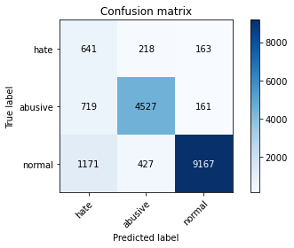

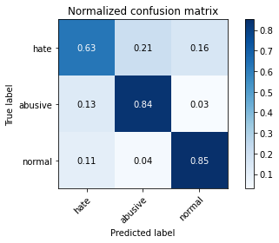

precision recall f1-score support

hate 0.25 0.63 0.36 1022

abusive 0.88 0.84 0.86 5407

normal 0.97 0.85 0.91 10765

accuracy 0.83 17194

macro avg 0.70 0.77 0.71 17194

weighted avg 0.90 0.83 0.86 17194

average eval_loss: 0.7996865548632043, accuracy: 0.8337210654879609

training 9 epoch...

151.5194160938263 seconds used......

9 training finished! average train loss: 0.07340831530457005

evaluating...

Confusion matrix, without normalization

[[ 694 182 146]

[ 934 4273 200]

[1751 286 8728]]

Normalized confusion matrix

[[0.67906067 0.17808219 0.14285714]

[0.17273904 0.79027187 0.03698909]

[0.16265676 0.02656758 0.81077566]]

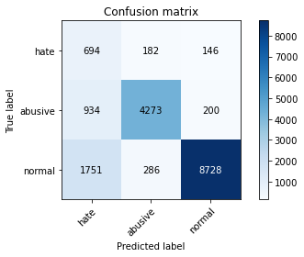

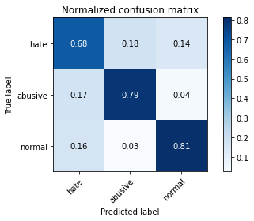

precision recall f1-score support

hate 0.21 0.68 0.32 1022

abusive 0.90 0.79 0.84 5407

normal 0.96 0.81 0.88 10765

accuracy 0.80 17194

macro avg 0.69 0.76 0.68 17194

weighted avg 0.90 0.80 0.83 17194

average eval_loss: 1.0423175701931076, accuracy: 0.7964987786437129

training 10 epoch...

151.54975271224976 seconds used......

10 training finished! average train loss: 0.07022335267356128

evaluating...

Confusion matrix, without normalization

[[ 678 205 139]

[ 898 4384 125]

[1676 468 8621]]

Normalized confusion matrix

[[0.66340509 0.20058708 0.13600783]

[0.16608101 0.81080081 0.02311818]

[0.15568974 0.04347422 0.80083604]]

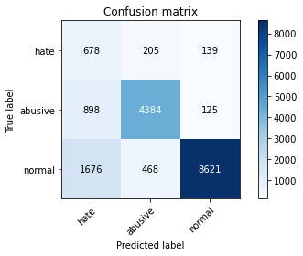

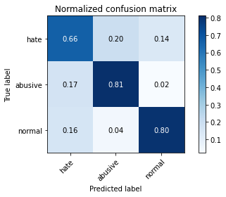

precision recall f1-score support

hate 0.21 0.66 0.32 1022

abusive 0.87 0.81 0.84 5407

normal 0.97 0.80 0.88 10765

accuracy 0.80 17194

macro avg 0.68 0.76 0.68 17194

weighted avg 0.89 0.80 0.83 17194

average eval_loss: 0.9262064532447216, accuracy: 0.7958008607653833

4 run

training 1 epoch...

151.30364894866943 seconds used......

1 training finished! average train loss: 0.6007264208040173

evaluating...

Confusion matrix, without normalization

[[ 482 284 256]

[ 301 4833 273]

[ 372 317 10076]]

Normalized confusion matrix

[[0.47162427 0.2778865 0.25048924]

[0.05566858 0.89384132 0.05049011]

[0.03455643 0.02944728 0.93599628]]

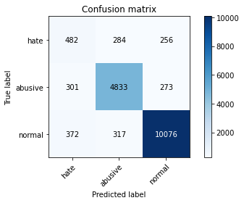

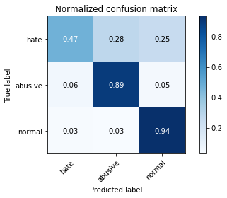

precision recall f1-score support

hate 0.42 0.47 0.44 1022

abusive 0.89 0.89 0.89 5407

normal 0.95 0.94 0.94 10765

accuracy 0.90 17194

macro avg 0.75 0.77 0.76 17194

weighted avg 0.90 0.90 0.90 17194

average eval_loss: 0.3305210345533005, accuracy: 0.8951378387809701

training 2 epoch...

151.25573825836182 seconds used......

2 training finished! average train loss: 0.44163022770569504

evaluating...

Confusion matrix, without normalization

[[ 631 218 173]

[ 573 4648 186]

[ 934 292 9539]]

Normalized confusion matrix

[[0.61741683 0.21330724 0.16927593]

[0.10597374 0.85962641 0.03439985]

[0.08676266 0.02712494 0.8861124 ]]

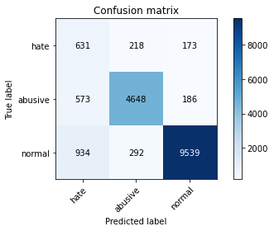

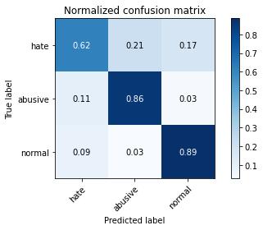

precision recall f1-score support

hate 0.30 0.62 0.40 1022

abusive 0.90 0.86 0.88 5407

normal 0.96 0.89 0.92 10765

accuracy 0.86 17194

macro avg 0.72 0.79 0.73 17194

weighted avg 0.90 0.86 0.88 17194

average eval_loss: 0.39637832483060137, accuracy: 0.8618122600907293

training 3 epoch...

151.38751554489136 seconds used......

3 training finished! average train loss: 0.3210507330335424

evaluating...

Confusion matrix, without normalization

[[ 794 150 78]

[1035 4300 72]

[2516 405 7844]]

Normalized confusion matrix

[[0.77690802 0.14677104 0.07632094]

[0.19141853 0.7952654 0.01331607]

[0.23372039 0.03762192 0.72865769]]

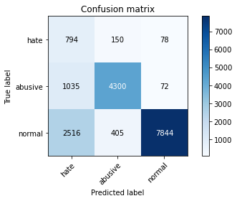

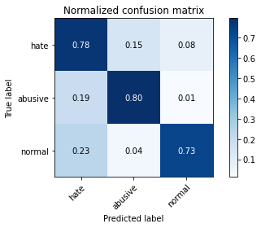

precision recall f1-score support

hate 0.18 0.78 0.30 1022

abusive 0.89 0.80 0.84 5407

normal 0.98 0.73 0.84 10765

accuracy 0.75 17194

macro avg 0.68 0.77 0.66 17194

weighted avg 0.90 0.75 0.80 17194

average eval_loss: 0.7068918836844522, accuracy: 0.7524717924857508

training 4 epoch...

151.43876957893372 seconds used......

4 training finished! average train loss: 0.21973914377660433

evaluating...

Confusion matrix, without normalization

[[ 748 160 114]

[1042 4248 117]

[2028 298 8439]]

Normalized confusion matrix

[[0.73189824 0.15655577 0.11154599]

[0.19271315 0.78564823 0.02163862]

[0.1883883 0.0276823 0.7839294 ]]

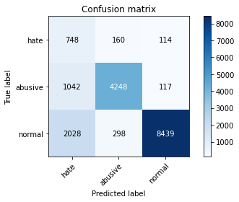

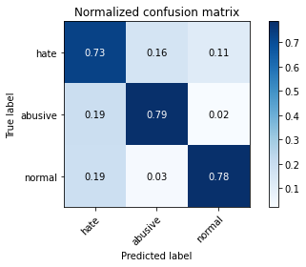

precision recall f1-score support

hate 0.20 0.73 0.31 1022

abusive 0.90 0.79 0.84 5407

normal 0.97 0.78 0.87 10765

accuracy 0.78 17194

macro avg 0.69 0.77 0.67 17194

weighted avg 0.90 0.78 0.83 17194

average eval_loss: 0.7535866180997949, accuracy: 0.7813772246132372

training 5 epoch...

151.52278900146484 seconds used......

5 training finished! average train loss: 0.1425762488790546

evaluating...

Confusion matrix, without normalization

[[ 657 247 118]

[ 729 4555 123]

[1721 456 8588]]

Normalized confusion matrix

[[0.64285714 0.24168297 0.11545988]

[0.13482523 0.84242648 0.02274829]

[0.15986995 0.0423595 0.79777055]]

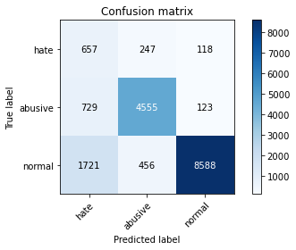

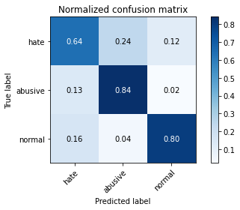

precision recall f1-score support

hate 0.21 0.64 0.32 1022

abusive 0.87 0.84 0.85 5407

normal 0.97 0.80 0.88 10765

accuracy 0.80 17194

macro avg 0.68 0.76 0.68 17194

weighted avg 0.89 0.80 0.84 17194

average eval_loss: 0.7957988266118391, accuracy: 0.8026055600790973

training 6 epoch...

151.42108345031738 seconds used......

6 training finished! average train loss: 0.11177072153609607

evaluating...

Confusion matrix, without normalization

[[ 674 191 157]

[ 962 4286 159]

[1293 353 9119]]

Normalized confusion matrix

[[0.65949119 0.18688845 0.15362035]

[0.17791751 0.79267616 0.02940633]

[0.12011147 0.03279145 0.84709707]]

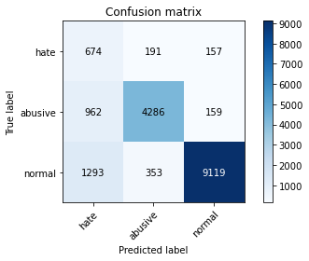

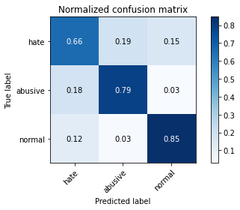

precision recall f1-score support

hate 0.23 0.66 0.34 1022

abusive 0.89 0.79 0.84 5407

normal 0.97 0.85 0.90 10765

accuracy 0.82 17194

macro avg 0.69 0.77 0.69 17194

weighted avg 0.90 0.82 0.85 17194

average eval_loss: 0.7915430314968839, accuracy: 0.8188321507502617

training 7 epoch...

151.33153414726257 seconds used......

7 training finished! average train loss: 0.0841253513416946

evaluating...

Confusion matrix, without normalization

[[ 743 166 113]

[1142 4130 135]

[1848 352 8565]]

Normalized confusion matrix

[[0.72700587 0.16242661 0.11056751]

[0.21120769 0.76382467 0.02496763]

[0.17166744 0.03269856 0.795634 ]]

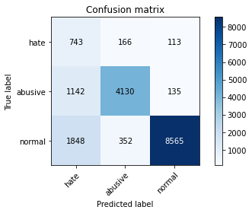

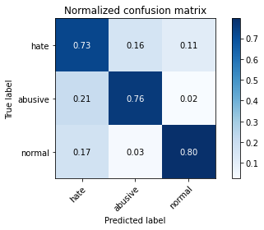

precision recall f1-score support

hate 0.20 0.73 0.31 1022

abusive 0.89 0.76 0.82 5407

normal 0.97 0.80 0.87 10765

accuracy 0.78 17194

macro avg 0.69 0.76 0.67 17194

weighted avg 0.90 0.78 0.82 17194

average eval_loss: 1.0291221649580917, accuracy: 0.7815517040828196

training 8 epoch...

151.28510284423828 seconds used......

8 training finished! average train loss: 0.07523754668899267

evaluating...

Confusion matrix, without normalization

[[ 719 175 128]

[1064 4204 139]

[1619 354 8792]]

Normalized confusion matrix

[[0.7035225 0.17123288 0.12524462]

[0.19678195 0.77751063 0.02570742]

[0.1503948 0.03288435 0.81672085]]

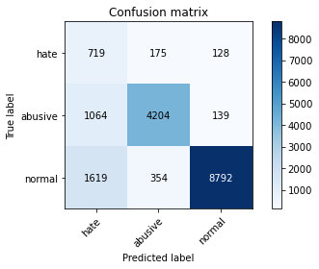

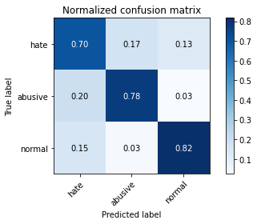

precision recall f1-score support

hate 0.21 0.70 0.33 1022

abusive 0.89 0.78 0.83 5407

normal 0.97 0.82 0.89 10765

accuracy 0.80 17194

macro avg 0.69 0.77 0.68 17194

weighted avg 0.90 0.80 0.84 17194

average eval_loss: 0.9885171021107411, accuracy: 0.7976619751075956

training 9 epoch...

151.47758984565735 seconds used......

9 training finished! average train loss: 0.06652017401685859

evaluating...

Confusion matrix, without normalization

[[ 697 186 139]

[ 892 4344 171]

[1546 354 8865]]

Normalized confusion matrix

[[0.68199609 0.18199609 0.13600783]

[0.16497133 0.803403 0.03162567]

[0.14361356 0.03288435 0.82350209]]

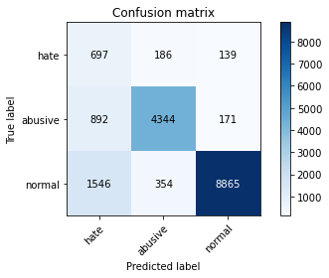

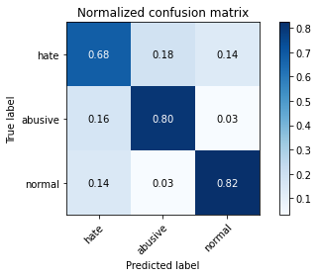

precision recall f1-score support

hate 0.22 0.68 0.34 1022

abusive 0.89 0.80 0.84 5407

normal 0.97 0.82 0.89 10765

accuracy 0.81 17194

macro avg 0.69 0.77 0.69 17194

weighted avg 0.90 0.81 0.84 17194

average eval_loss: 0.9439858179160415, accuracy: 0.8087705013376759

training 10 epoch...

151.25431632995605 seconds used......

10 training finished! average train loss: 0.0584623631479247

evaluating...

Confusion matrix, without normalization

[[ 641 201 180]

[ 877 4333 197]

[1075 343 9347]]

Normalized confusion matrix

[[0.62720157 0.19667319 0.17612524]

[0.16219715 0.8013686 0.03643425]

[0.09986066 0.03186252 0.86827682]]

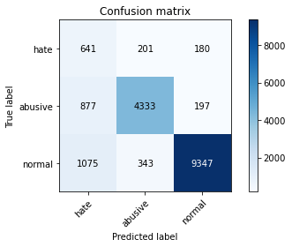

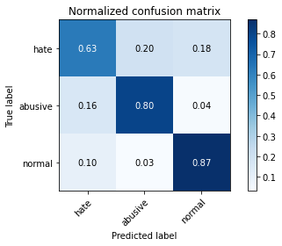

precision recall f1-score support

hate 0.25 0.63 0.35 1022

abusive 0.89 0.80 0.84 5407

normal 0.96 0.87 0.91 10765

accuracy 0.83 17194

macro avg 0.70 0.77 0.70 17194

weighted avg 0.90 0.83 0.86 17194

average eval_loss: 0.900547646054711, accuracy: 0.832906827963243

5 run

training 1 epoch...

151.4902982711792 seconds used......

1 training finished! average train loss: 0.6196730829455782

evaluating...

Confusion matrix, without normalization

[[ 676 189 157]

[ 770 4492 145]

[1078 301 9386]]

Normalized confusion matrix

[[0.66144814 0.18493151 0.15362035]

[0.14240799 0.83077492 0.02681709]

[0.10013934 0.02796098 0.87189967]]

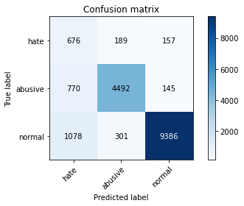

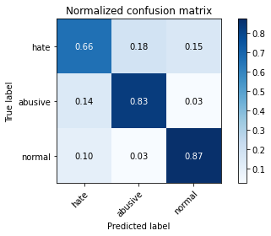

precision recall f1-score support

hate 0.27 0.66 0.38 1022

abusive 0.90 0.83 0.86 5407

normal 0.97 0.87 0.92 10765

accuracy 0.85 17194

macro avg 0.71 0.79 0.72 17194

weighted avg 0.91 0.85 0.87 17194

average eval_loss: 0.42714782232461973, accuracy: 0.846458066767477

training 2 epoch...

151.4055347442627 seconds used......

2 training finished! average train loss: 0.4453882048112544

evaluating...

Confusion matrix, without normalization

[[ 730 170 122]

[ 929 4350 128]

[1476 300 8989]]

Normalized confusion matrix

[[0.71428571 0.16634051 0.11937378]

[0.17181431 0.80451267 0.02367302]

[0.13711101 0.02786809 0.8350209 ]]

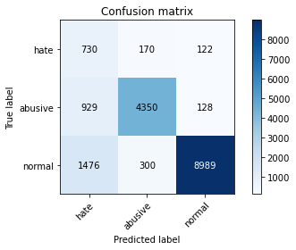

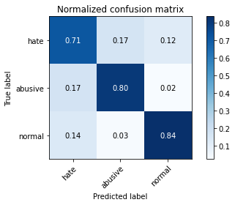

precision recall f1-score support

hate 0.23 0.71 0.35 1022

abusive 0.90 0.80 0.85 5407

normal 0.97 0.84 0.90 10765

accuracy 0.82 17194

macro avg 0.70 0.78 0.70 17194

weighted avg 0.91 0.82 0.85 17194

average eval_loss: 0.49267592416253203, accuracy: 0.8182505525183204

training 3 epoch...

151.27573370933533 seconds used......

3 training finished! average train loss: 0.32060862616814556

evaluating...

Confusion matrix, without normalization

[[ 638 226 158]

[ 620 4617 170]

[1184 321 9260]]

Normalized confusion matrix

[[0.62426614 0.22113503 0.15459883]

[0.11466617 0.8538931 0.03144072]

[0.10998607 0.02981886 0.86019508]]

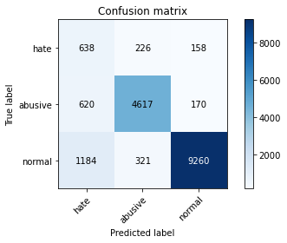

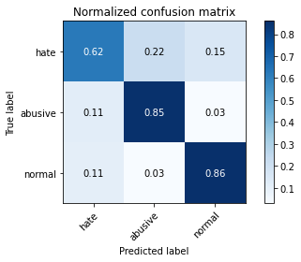

precision recall f1-score support

hate 0.26 0.62 0.37 1022

abusive 0.89 0.85 0.87 5407

normal 0.97 0.86 0.91 10765

accuracy 0.84 17194

macro avg 0.71 0.78 0.72 17194

weighted avg 0.90 0.84 0.87 17194

average eval_loss: 0.4854688487188934, accuracy: 0.8441898336629057

training 4 epoch...

151.20301461219788 seconds used......

4 training finished! average train loss: 0.2077967346715268

evaluating...

Confusion matrix, without normalization

[[ 724 150 148]

[1159 4088 160]

[1390 318 9057]]

Normalized confusion matrix

[[0.70841487 0.14677104 0.14481409]

[0.21435177 0.75605696 0.02959127]

[0.12912216 0.02954018 0.84133767]]

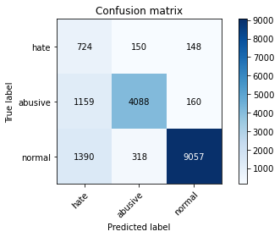

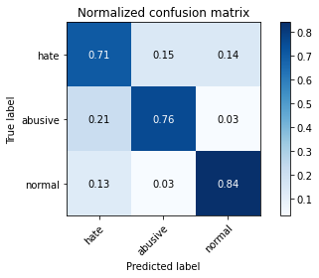

precision recall f1-score support

hate 0.22 0.71 0.34 1022

abusive 0.90 0.76 0.82 5407

normal 0.97 0.84 0.90 10765

accuracy 0.81 17194

macro avg 0.70 0.77 0.69 17194

weighted avg 0.90 0.81 0.84 17194

average eval_loss: 0.6881621759947996, accuracy: 0.8066185878794928

training 5 epoch...

151.15954113006592 seconds used......

5 training finished! average train loss: 0.14179662506581697

evaluating...

Confusion matrix, without normalization

[[ 629 263 130]

[ 524 4737 146]

[1417 445 8903]]

Normalized confusion matrix

[[0.61545988 0.25733855 0.12720157]

[0.09691141 0.87608655 0.02700203]

[0.13163028 0.04133767 0.82703205]]

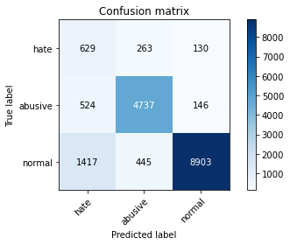

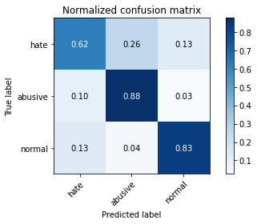

precision recall f1-score support

hate 0.24 0.62 0.35 1022

abusive 0.87 0.88 0.87 5407

normal 0.97 0.83 0.89 10765

accuracy 0.83 17194

macro avg 0.69 0.77 0.71 17194

weighted avg 0.90 0.83 0.85 17194

average eval_loss: 0.6997364076146813, accuracy: 0.8298825171571479

training 6 epoch...

151.41321897506714 seconds used......

6 training finished! average train loss: 0.09946090445073813

evaluating...

Confusion matrix, without normalization

[[ 562 248 212]

[ 592 4618 197]

[ 779 394 9592]]

Normalized confusion matrix

[[0.54990215 0.24266145 0.2074364 ]

[0.1094877 0.85407805 0.03643425]

[0.07236414 0.03660009 0.89103576]]

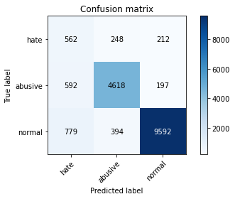

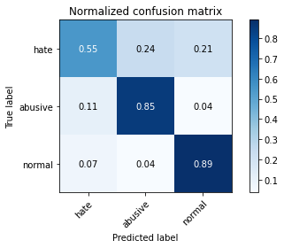

precision recall f1-score support

hate 0.29 0.55 0.38 1022

abusive 0.88 0.85 0.87 5407

normal 0.96 0.89 0.92 10765

accuracy 0.86 17194

macro avg 0.71 0.77 0.72 17194

weighted avg 0.89 0.86 0.87 17194

average eval_loss: 0.5816841107522419, accuracy: 0.859136908223799

training 7 epoch...

151.23010730743408 seconds used......

7 training finished! average train loss: 0.07796278588947342

evaluating...

Confusion matrix, without normalization

[[ 671 231 120]

[ 779 4514 114]

[1815 560 8390]]

Normalized confusion matrix

[[0.65655577 0.2260274 0.11741683]

[0.1440725 0.83484372 0.02108378]

[0.16860195 0.05202044 0.77937761]]

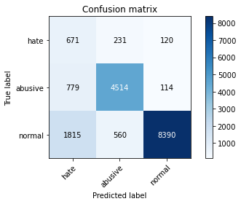

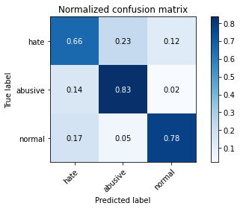

precision recall f1-score support

hate 0.21 0.66 0.31 1022

abusive 0.85 0.83 0.84 5407

normal 0.97 0.78 0.87 10765

accuracy 0.79 17194

macro avg 0.68 0.76 0.67 17194

weighted avg 0.89 0.79 0.83 17194

average eval_loss: 0.9820809166878461, accuracy: 0.7895195998604164

training 8 epoch...

151.21437287330627 seconds used......

8 training finished! average train loss: 0.07238838656460678

evaluating...

Confusion matrix, without normalization

[[ 679 208 135]

[ 763 4495 149]

[1584 415 8766]]

Normalized confusion matrix

[[0.66438356 0.2035225 0.13209393]

[0.14111337 0.83132976 0.02755687]

[0.14714352 0.03855086 0.81430562]]

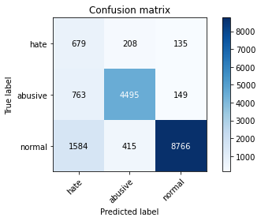

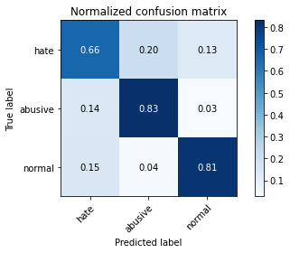

precision recall f1-score support

hate 0.22 0.66 0.34 1022

abusive 0.88 0.83 0.85 5407

normal 0.97 0.81 0.88 10765

accuracy 0.81 17194

macro avg 0.69 0.77 0.69 17194

weighted avg 0.90 0.81 0.84 17194

average eval_loss: 0.8949883760028887, accuracy: 0.8107479353262766

training 9 epoch...

151.42713022232056 seconds used......

9 training finished! average train loss: 0.0615133217179309

evaluating...

Confusion matrix, without normalization

[[ 683 195 144]

[ 849 4403 155]

[1390 422 8953]]

Normalized confusion matrix

[[0.66829746 0.19080235 0.1409002 ]

[0.15701868 0.81431478 0.02866654]

[0.12912216 0.03920111 0.83167673]]

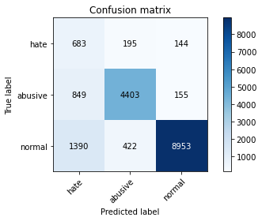

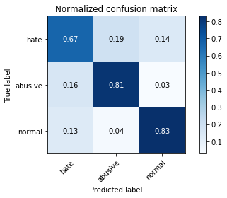

precision recall f1-score support

hate 0.23 0.67 0.35 1022

abusive 0.88 0.81 0.84 5407

normal 0.97 0.83 0.89 10765

accuracy 0.82 17194

macro avg 0.69 0.77 0.70 17194

weighted avg 0.90 0.82 0.85 17194

average eval_loss: 0.992413463212853, accuracy: 0.8165057578224962

training 10 epoch...

151.45014834403992 seconds used......

10 training finished! average train loss: 0.061605528318670076

evaluating...

Confusion matrix, without normalization

[[ 738 196 88]

[1073 4244 90]

[2177 675 7913]]

Normalized confusion matrix

[[0.7221135 0.19178082 0.08610568]

[0.19844646 0.78490845 0.01664509]

[0.20222945 0.0627032 0.73506735]]

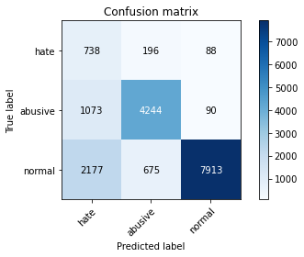

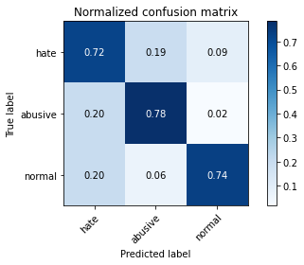

precision recall f1-score support

hate 0.19 0.72 0.29 1022

abusive 0.83 0.78 0.81 5407

normal 0.98 0.74 0.84 10765

accuracy 0.75 17194

macro avg 0.66 0.75 0.65 17194

weighted avg 0.88 0.75 0.80 17194

average eval_loss: 1.3207153073447042, accuracy: 0.7499709200884029